Session 01:

JAVA INTRODUCTION

# Download & Install Java Development Kit JDK in Windows

This tutorial will guide you step by step how to download and install [Java Development Kit (JDK)](https://www.scientecheasy.com/2021/03/what-is-jdk.html/) in Windows. The Java JDK allows you to develop Java applications and run them.

If you installed multiple JDK versions on the same PC, we recommend that you install the only latest version of JDK. Before going to download. we need to have the following:

1. Internet browsers like Firefox, Google Chrome, or Internet Explorer.

2. Internet Connection to download and install.

## Download & Install Java JDK in Windows

Follow all the below steps to complete the download and installation of Java Software Development Kit (JDK) in Windows:

**Steps:**

1. Visit the Oracle download page in your browser and download the latest version of JDK from the following link:  
<https://www.oracle.com/technetwork/java/javase/downloads/index.html>

[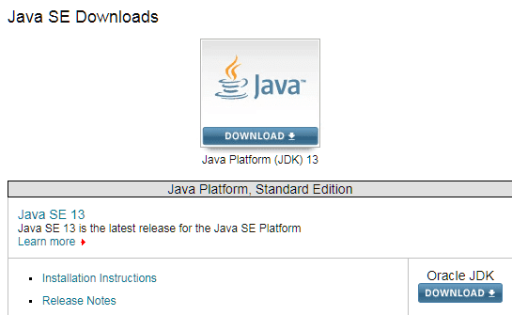](https://www.scientecheasy.com/2020/07/download-java-development-kit.html/)

2. Accept License Agreement and download the latest Java JDK for your version (64 bit) of java for Windows.

[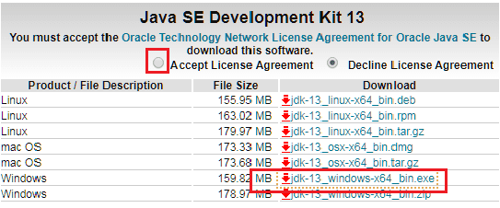](https://www.scientecheasy.com/2020/07/download-java-development-kit.html/)

The type of installation may depend on your system requirements and platform that you will choose to install.

Once the JDK exe file has been downloaded to your computer from the website, double click on the downloaded exe file and run the installation of Java software on your computer.

3. You must follow all the instructions provided by the installation wizard.

4. Once the installation process is completed, check the program files folder of C:/ Drive. This folder must contain a Java folder with JDK and JRE sub-folders.

If you see these sub-folders in your C:/ Drive’s program files folder, it means that the installation of Java is completed. Now, you can delete the downloaded file to recover the disk space.

5. In the third step, you will have to check the Java configuration to make sure that the Java files are identified by the computer or not.

For this, you will have to set the PATH variable permanently for JDK 13 so that it is persistent after reboot.

If you do not set the PATH variable, then you must have to specify the full path every time to execute program that you run it.

For example:

C:> “C:\Program Files\Java\jdk-13\bin\javac” MyClass.java

So, let’s set the full path in the system.

## How to set Path and Classpath in Environment Variables for Java?

Once the Java Software Development Kit has been installed successfully, the next step is to set up Path and Classpath in environment variables permanently in your system.

Environment variables are special Windows operating system variables that are used to identify the installation directory, location of temporary files, tools, and profile settings.

They contain values that can be used by programs. Since the value of environment variable is changeable and updateable, environment variable is dynamic in nature.

Some of the common environment variables are as follows:

1. %appdata%: Location of Application Data folder for your user profile.  
2. %commonprogramfiles%: Location of Common Files folder, within the main Program Files folder.  
3. %path%: Location of various tools e.g. Java tools.  
4. %programfiles%: Location of where programs are installed.  
5. %temp%: Location of temporary files.  
6. %windir%: Location of windows system files.

The Path variable gives the location of the bin folder and the Classpath variable gives the location of Java files.

Whenever Java programs are compiled and executed on the computer, the computer needs to know where java files are located and what is respective PATH of bin folder?

So, Java file location (library files) is provided through the ClASSPATH variable.

## Steps to set Path variable on Microsoft Windows

Path variable gives the location of tools. Specifically, it identifies the location of  Java compiler (Javac.exe) and java interpreter (Java.exe).

There are two ways to set path variable that are as follows:

1. Control Panel
2. Command Line

### Setting Path using Control panel:

Setting the Path variable using control panel is a superior way because it will be permanent. Follow all the steps below to set the PATH variable using the control panel on Microsoft Windows:

1. Go to the Start menu and navigate to the Control panel.

2. In the Control panel, you will see a System icon. Now double-click on this icon.

3. Go to the Advanced system setting and click on it. You can see the below screenshot.

[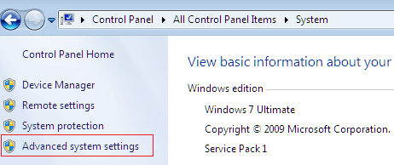](https://www.scientecheasy.com/2020/07/download-java-development-kit.html/)

4. A system properties dialog window box will be displayed as shown in the below screenshot.

[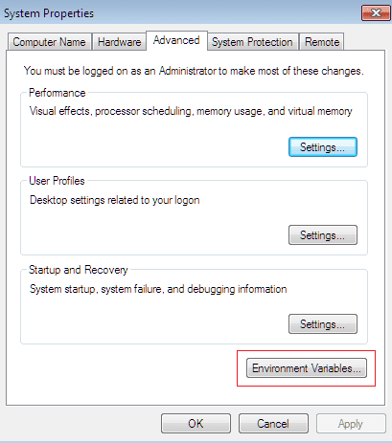](https://www.scientecheasy.com/2020/07/download-java-development-kit.html/)

5. Click on the Environment variables.

6. Now click on the New button in System variable. You will see a new window dialog box “New System Variable” as shown in the below screenshot.

[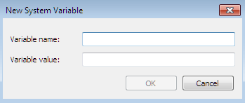](https://www.scientecheasy.com/2020/07/download-java-development-kit.html/)

7. Write “PATH” as a variable name and enter the location of the JDK bin folder in the variable value. A typical value for the PATH variable is shown below:

C:\ProgramFiles\Java\jdk-13\bin

Now click on the OK button.

**Note:** In case you have already created a PATH variable in your system, edit the PATH variable to

PATH = <JDK installation directory>bin;%PATH%; Here, %PATH% join the existing path variable to our new value. You must have only one bin directory for a JDK in the path at a time.

8. You can follow similar steps to set CLASSPATH. Write “CLASSPATH” as a variable name and enter the location of the JDK lib folder in the variable value.

The following is a typical value for the CLASSPATH variable:

C:\ProgramFiles\Java\jdk-13\lib

Now click on OK button.

### Setting Path variable using Command Line:

Setting Path variable using the command line is temporary. It can be set using SET command. The SET command is not case sensitive.

This technique can apply only at the current command line. Let’s understand how to set Path variable at the command line.

For example:

Set path=C:\ProgramFiles\Java\jdk-13\bin;

Similarly for classpath:

Set classpath=C:\ProgramFiles\Java\jdk-13\lib;

Hope that this tutorial has covered almost all the important points to download and install Java Development Kit (JDK) on the computer system. I hope that you will have also understood how to set path in environment variables permanently.

# First Simple Java Program Hello World

In this tutorial, we will learn how to write the first simple program in Java. Writing a simple program in Java is very easy as in other languages.

We need to create a class that contains the [main method](https://www.scientecheasy.com/2020/06/main-method-in-java.html/) of valid signature which acts as an entry point for the program.

So, we will start with a very simple program that will print a line of text (“Hello Java”) as output.

Before going to create a class, we will understand the requirements first.

## Requirements for Simple Java Program

Following are four steps needed for creating and executing any program in java.

1. Install the JDK. If you don’t have installed it, download the JDK and install it. Go to this tutorial: [Download and Install JDK](https://www.scientecheasy.com/2020/07/download-java-development-kit.html/).
2. Set the path of the jdk/bin directory.
3. Writing the java program.
4. Compiling java program.
5. Running bytecode on JVM.

[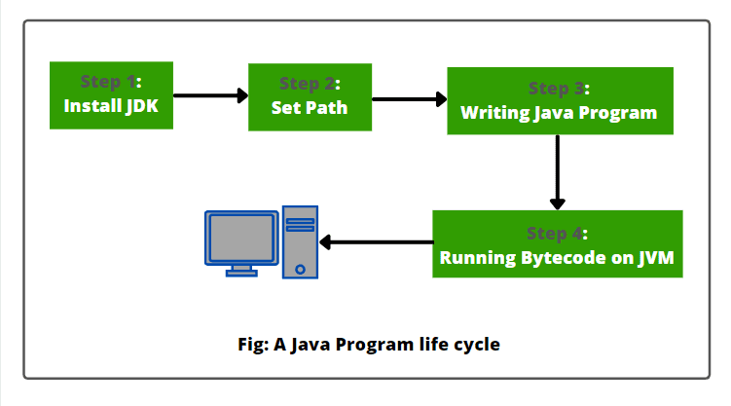](https://www.scientecheasy.com/2021/04/java-program-hello-world.html/)

## Simple Java Hello World Example

Let’s write a HelloWorld Program. To write a simple java program, we can use any text editor like Notepad on Windows and TextEdit on Mac. Now, open a text editor and write a simple program.

A simple Java program looks like as shown below. It contains one class that contains a main() method.

class Hello  {  // Start class definition.

public static void main(String args[])

{

System.out.println("Hello World");

}

}  // End class definition.

Save this file as Hello.java

A Java program must be saved with .java extension. The extension is case-sensitive. It is compiled using the Java compiler (javac.exe) and executed using Java interpreter (java.exe).

If Java program does not have valid extension (.java), [Java compiler](https://www.scientecheasy.com/2021/03/java-compiler.html/) generates an error on compiling.

For example, suppose the above program is saved with .java extension then the compiler will generate an error because the file extension is case sensitive. A valid extension for Java program is .java.

**Note:** File name must be the same as the program name and the extension must be .java. This file is called source file or source code. Source code is Java code written by a programmer.

Now the next step is to compile Java program. So, let’s understand it step by step.

## How to Compile Java Program?

To compile the above program, we need to call Java compiler to translate (converts) program source code into Java bytecode.

For this, open **Command prompt** (cmd) on Windows. If you are using Mac OS then open Terminal.

To compile the above program, write the following command and press enter.

To compile: javac Hello.java

You may get this error while compiling this program: “**javac’ is not recognized as an internal or external command, operable program or batch file**“.

Generally, this error happens when the java path is not set properly in your system. If you get this error then you first set the path properly before going to compile the above program.

If everything is fine, the javac compiler will create a file called **Hello.class** on your disk. This file contains the byte code of the program.

The compiled java program source code is called bytecode. Java compiler automatically names the byte code file.

**Note:** If the program contains syntax errors then it will not compile. A syntax error generally occurs in a statement when we violate the rules of Java.

For example, all the java statements must end with a semicolon. A statement without a semicolon produces a syntax error during the compilation of program and prevents the compiler from generating bytecode for the program.

Now the next step is to run (execute) the Java program.

## How to Run Java Program?

In the final step, we can run the program. For this, we need to use [Java interpreter](https://www.scientecheasy.com/2021/04/interpreter-in-java.html/) to execute a standalone program. At the command prompt, type the following command and press the enter key.

To execute: java Hello

Now, Java interpreter will search the main method in the application program and starts the execution process from there.

When the program is executed in [JVM](https://www.scientecheasy.com/2021/03/what-is-jvm.html/), it will display the following line of text on your computer screen.

Output:

Hello Java

## Process of Java Program Compilation and Execution

1. When we compile source code (Hello.java file) using javac compiler, Java compiler automatically generates bytecode (Hello.class) on the local disk.

A byte code is a binary code that is understood by Java interpreter with the help of JVM.

2. Java Interpreter takes byte code as an input and executes that code by converting it to native code with the underlying operating system. In simple words, byte code is processed by Java interpreter.

Since this bytecode is machine-independent, it can be run on any computer machine. In other words, a program compiled on one machine can be run on another machine.

Look at the compilation and execution flow diagram below.

[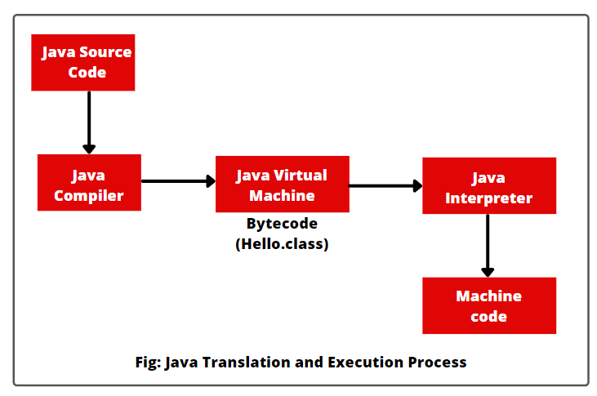](https://www.scientecheasy.com/2021/04/java-program-hello-world.html/)

## Important Statements used in Hello Program

Perhaps, the above program is one of the simplest of all Java programs. Let’s understand the statements of program line by line and the unique features provided by Java language.

**1. Class Declaration:**

The first line is

public class Hello

This statement declares a class named Hello. Here, class is a keyword in Java that is used to define a class.

Hello is a [Java identifier](https://www.scientecheasy.com/2021/04/identifiers-in-java.html/) that represents the name of class to be defined. Since Java is a true object-oriented programming language, everything must be placed inside a class.

**2. Opening Brace:**

Every class definition starts with an opening brace ” { ” and ends with a matching closing brace ” { “. It is just like to C++ class construct. Remember that a class definition in C++ ends with a semicolon.

**3. Main method (Main line):**

The third line is

public static void main(String[] args)

This statement defines the main() method. It is automatically run when the program is executed. It is similar to the main() function in C/C++.

Every Java program must have the main() method. It is the starting point for the interpreter to start the execution process of java program.

A Java program may contain any number of classes but only one of them must contain the main method to begin the execution.

This statement contains a number of keywords such as public, static, and void.

a) **public:** The keyword public is an access modifier that represents visibility. It means it is accessible to all other classes.

b) **static:** It is a keyword. If we define a method as static, it is called static method. The main advantage of the static method is that there is no need to create an object to call the static method.

The main method must always be declared as static because JVM executes the static method before the object creation. It means that JVM doesn’t need to create an object to class the main method. Thus, it also saves memory.

c) **void:** It is a modifier that states that the main method does not return any value.

d) **main:** It represents the starting point for the execution of the program.

e) **String[] args:** It contains an array of objects of class type String. It is used for command-line arguments.

If you try out to make the main method upper case, Java compiler will generate compile-time error.

The valid “main” methods that can be used in a Java program are

1. public static void main(String[] args)
2. public static void main(String args[])
3. public static void main(String …a)

At a time, only one of the above “main” method can be used in a class.

**4. Output Line:**

Inside the main method, the only executable statement is

System.out.println("Hello Java");

The println() method is used to print (display) “Hello World” on the console. It is similar to the print() statement of C or court << construct of C++.

Since Java is a pure object-oriented programming language, every method is a part of an object. The println() method is a part of out object, that is a static data member of System class.

The statement prints the string: “Hello World” to the screen.

**5. Semicolon:**

A program is composed of a set of instructions that is called statements. A semicolon is needed to indicate the end of a statement. Every Java statement must end with a semicolon.

Hope that this tutorial has covered all the important points related to the first simple Java program: Hello world. I hope that you will have understood important statements used in Hello program.

# Download Eclipse IDE for Java Developers

Before going to **download Eclipse IDE**, let’s understand first in brief about Eclipse.

Eclipse is an IDE (Integrated Development Environment) supported by IBM.

It is used to develop software in any language such as Java, Android, C/C++, PHP, Python, Perl, and other web project developments via extensible plug-ins. It was open-sourced in November 2001.

Eclipse Foundation is an organization that controls eclipse independently. Today, it can be run in the most popular operating system like Windows, Mac OS, and Linux.

Eclipse is the most popular for Java application development (Java SE and Java EE). Therefore, first, you must install a recent version Java on your PC.

You can download and install the Java Software Development Kit (JDK) step by step from this link: [Download and Install Java Development Kit in Windows](https://www.scientecheasy.com/2020/07/download-java-development-kit.html/)

## How to Download Eclipse IDE for Windows 10

You follow all the steps given below to download and install Eclipse IDE on your computer pc.

1. Visit <https://www.eclipse.org/downloads> and download the latest version of “Eclipse IDE for Java Developers”. Make sure to choose correctly between Windows 32 Bit and 64 Bit versions.

[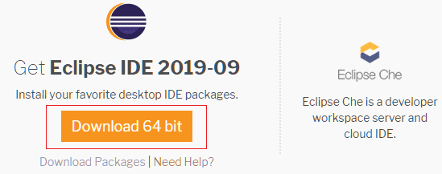](https://www.scientecheasy.com/2020/07/download-eclipse-ide.html/)

2. Once the download is completed, double-click on the file to Install the Eclipse. You may get a security warning to run this file. Select the Run option.

3. A new Eclipse Installer packages window will open to choose Eclipse IDE. Select and click on Eclipse IDE for Java Developers to install as shown in the below screenshot.

You can also search for the package you want to install by scrolling the list.[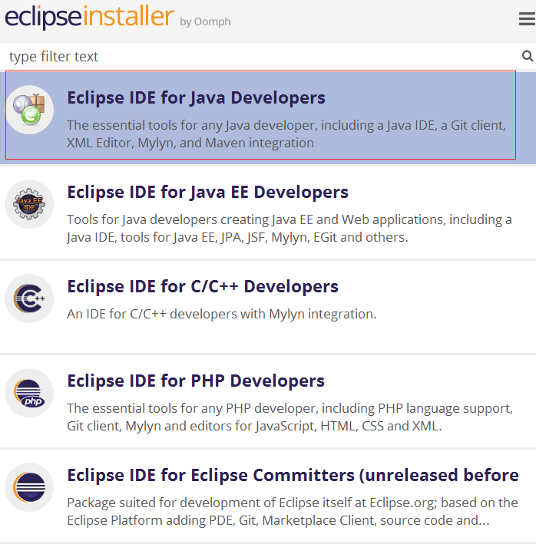](https://www.scientecheasy.com/2020/07/download-eclipse-ide.html/)

4. After that, a new window dialog box will open on your screen. You can specify any destination folder present on your system you want Eclipse to be installed.

Now click on the Install button to start the installation. The Set up is ready to install Eclipse in the directory shown in the below screenshot.

[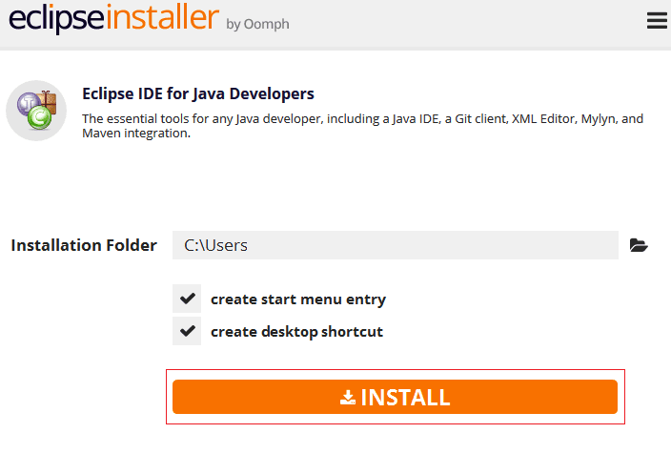](https://www.scientecheasy.com/2020/07/download-eclipse-ide.html/)

5. The setup will ask you to accept the Eclipse Foundation Software Agreement. Just click on Accept to continue the installation process.

Now, wait for some time to be installing Eclipse on our system.

6. Once the installation process will be successfully completed, a new window dialog box will appear on your screen as shown in the below screenshot.

On that window box, click on Launch button to launch the eclipse.

[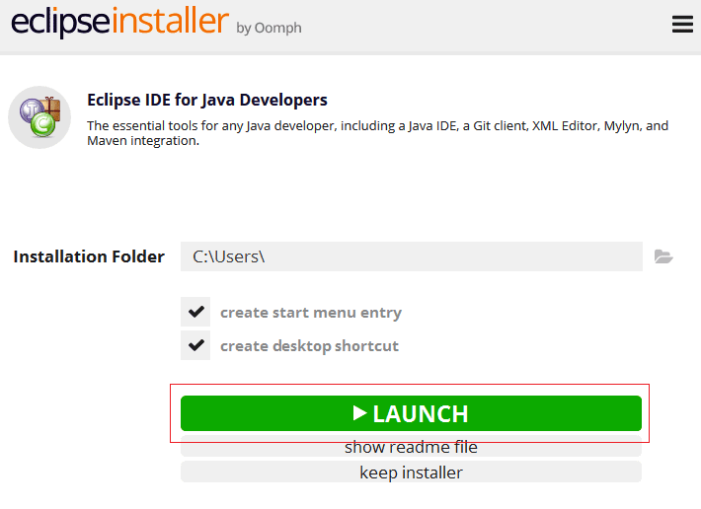](https://www.scientecheasy.com/2020/07/download-eclipse-ide.html/)

## How to Configure Eclipse for Java?

Follow all the steps to configure Eclipse for Java programming:

1. When you will start Eclipse for the first time, it will ask you where you want your workspace as shown in the below screenshot.

Workspace is that folder in your system where Eclipse will place data of your new projects you create. You can change the folder of the workspace by using browser if you want.

[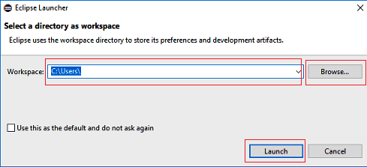](https://www.scientecheasy.com/2020/07/download-eclipse-ide.html/)

2. Now, you will see the “Welcome” on your screen. Just close the “welcome” tab to open the regular editor.

3. Now go to “Windows” at the top of Eclipse and choose the “Preferences” option.

[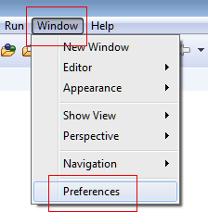](https://www.scientecheasy.com/2020/07/download-eclipse-ide.html/)

4. On the left-hand side, choose Java, click Install JREs and click the Add… button on the right side.

[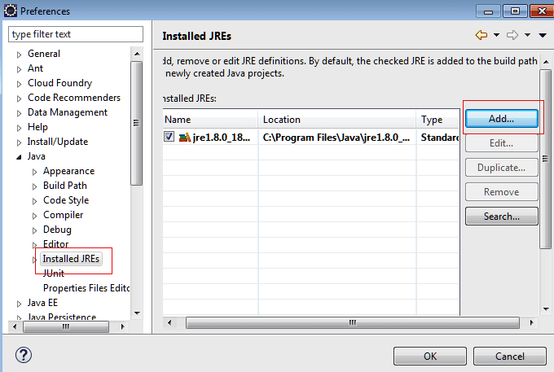](https://www.scientecheasy.com/2020/07/download-eclipse-ide.html/)

5. On the first page of the Windows popup wizard, choose “Standard VM”, then click on the Next button.

[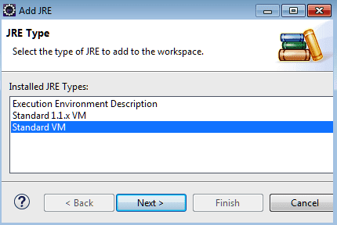](https://www.scientecheasy.com/2020/07/download-eclipse-ide.html/)

6. Next click on Directory, browse the folder for Java in program files, and select the root directory of the JRE installation, then press OK. You can see in the below screenshot.

[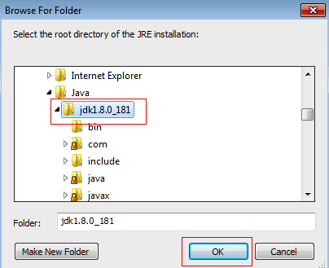](https://www.scientecheasy.com/2020/07/download-eclipse-ide.html/)

7. On the next page, verify JRE name and its all the System libraries jars are added properly by Eclipse itself or not. After that click Finish.

[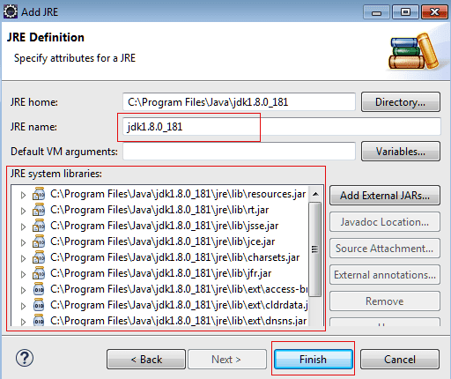](https://www.scientecheasy.com/2020/07/download-eclipse-ide.html/)

8. Check just created JDK added to build path and then press OK.

[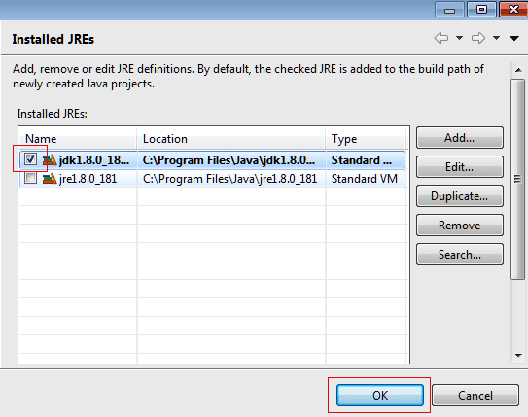](https://www.scientecheasy.com/2020/07/download-eclipse-ide.html/)

Hope that this tutorial has covered all the important points concerning **download and install Eclipse IDE** for Java developers. I hope that you will have installed Eclipse IDE on your PC successfully and enjoyed this tutorial.

# Simple Java Program in Eclipse | Compile, Run

We can edit, compile, run, and debug Java Programs using Eclipse and NetBeans.

Eclipse and NetBeans are two free popular integrated development environments for writing Java programs. Both are easy to learn if you follow simple instructions.

We recommend that you use either one for writing Java programs. In the first section, we will use Eclipse to develop a simple Java program.

We will guide you to essential instructions step by step to new users to create a project, create a class, compile, and run a class in Eclipse.

The use of NetBeans will be introduced in the next section.

## Requirements for Developing Simple Java Program in Eclipse

Following are some useful instructions needed for developing and executing a program in java:

a) Install the Eclipse IDE. If you don’t have installed it, download the Eclipse IDE and install it. For this, go to this tutorial: [Download and Install Eclipse IDE for Java](https://www.scientecheasy.com/2020/07/download-eclipse-ide.html/)

b) Writing the java program.

c) Compiling java program.

d) Run java program.

Hope that you have successfully installed Eclipse IDE by following all instructions. Now, we will understand to create a java project in Eclipse.

## How to create Java Project in Eclipse?

Before creating Java programs in Eclipse IDE, we need to first create a project. A project is like a folder structure that holds Java programs and all supporting files. We need to create a project only once.

Follow all the steps below to create a Java project in Eclipse:

1. First of all, open Eclipse IDE and choose File > New > Java Project to display the New Project wizard, as shown in Figure.

[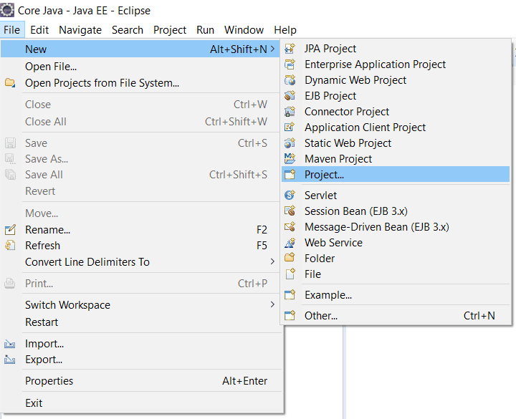](https://www.scientecheasy.com/2021/04/java-program-in-eclipse.html/)

2. A new project wizard will be displayed. Select java project and then click on Next button as shown in the below figure.

[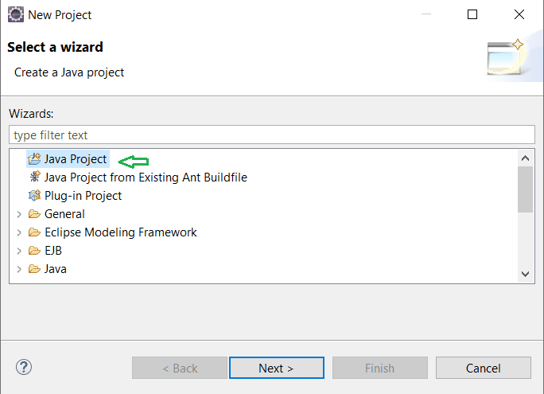](https://www.scientecheasy.com/2021/04/java-program-in-eclipse.html/)

3. Type Java Project in the Project name field. As we type, the location field will be automatically set by default. You may also customize the location for your project. Look at the below figure to understand better.

[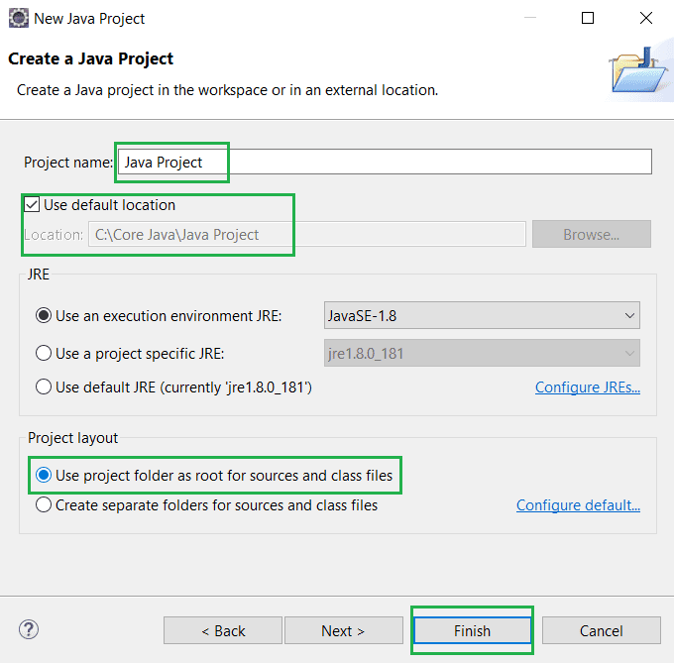](https://www.scientecheasy.com/2021/04/java-program-in-eclipse.html/)

4. Make sure that you chose the options Use project folder as root for sources and class files so that the .java and .class files are in the same folder for easy access.

4. Click on the Finish button to create the project, as shown in the above Figure.

Now java project is created with the src folder as shown in the below figure. The next step is to create a package folder.

[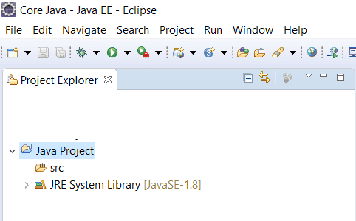](https://www.scientecheasy.com/2021/04/java-program-in-eclipse.html/)

## How to create Java Package in Eclipse?

Follow all the steps below to create a package in java in Eclipse IDE:

1. Right-click on the newly created Java project > New > Package. A new java package wizard will be open as shown in the below figure.

[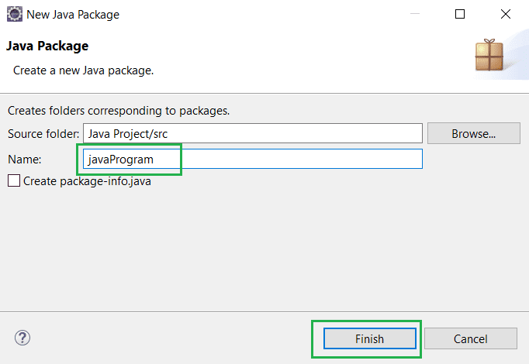](https://www.scientecheasy.com/2021/04/java-program-in-eclipse.html/)

2. Type a package name “javaProgram” and click on Finish button. A package folder named javaProgram is created on the left side.

We will learn how to create a package in java systematically in the further tutorial.

## How to create Java Class in Eclipse?

After the creation of package in the java project, we can create a program in java in the java project using the following steps:

1. Right-click on package name “javaProgram” and choose File > New > Class to display the New Java Class wizard.

[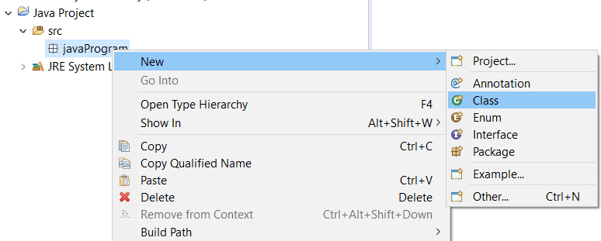](https://www.scientecheasy.com/2021/04/java-program-in-eclipse.html/)

2. Type Hello in the Name field > check the option public static void main(String[] args) as shown in the below figure.

[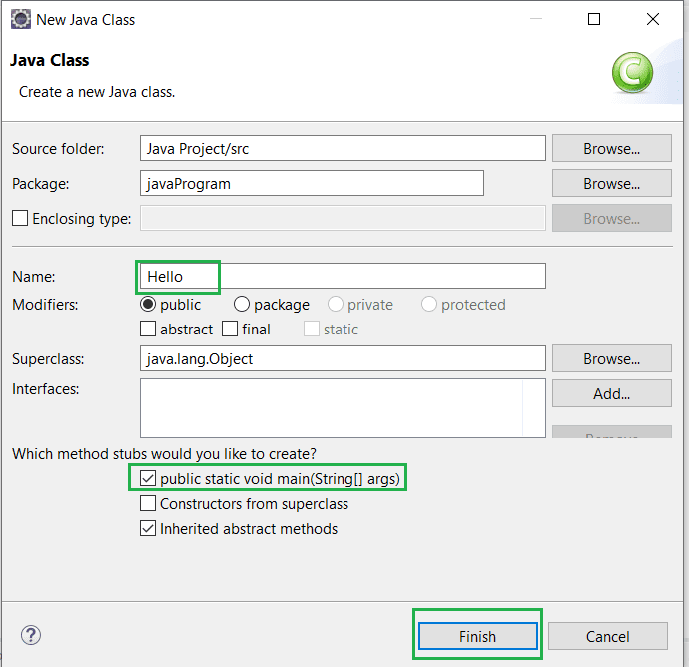](https://www.scientecheasy.com/2021/04/java-program-in-eclipse.html/)

3. Click on Finish button to produce template for the program source code named Hello.java.

A class named Hello.java will be created below the package name on the left-hand side.

Now we will write the first simple java program in the template as written in the following source code.

**Program source code:**

package javaProgram;

public class Hello {

public static void main(String[] args)

{

System.out.println("Hello World");

}

}

We have developed a simple java program in the Eclipse IDE. The next step is compiling and executing a java program.

## How to Compile and Run Java Program in Eclipse?

To run java program, right-click the class in the project to display a context menu. Choose Run As > Java Application in the context menu to run java program.

The output is displayed in the Console pane, as shown in the below figure.

[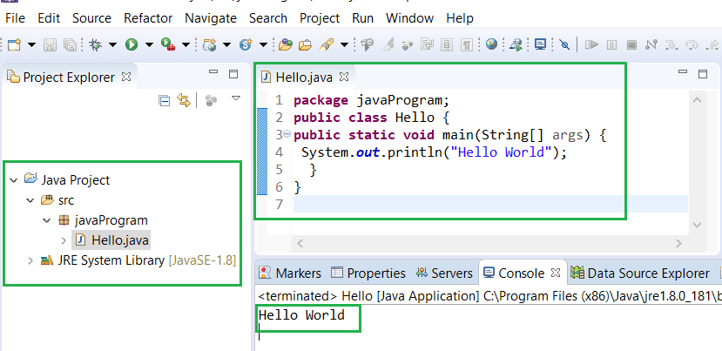](https://www.scientecheasy.com/2021/04/java-program-in-eclipse.html/)

## How to Create Java Project in NetBeans?

First of all, download and install the latest Apache NetBeans in your computer system as per computer configuration. For this go to this tutorial: [Download NetBeans](https://netbeans.apache.org/download/nb122/nb122.html)

Before developing a Java program, we need to first create a project. Here are the steps to create a Java project in NetBeans:

1. Choose File > New Project to display the New Project dialog box.

2. Select Java in the Categories section and Java Application in the Projects section. Click on Next button to display the New Java Application dialog box.

3. Type “Java Project” in the Project Name field and browse Project Location field as you want. Uncheck Use Dedicated Folder for Storing Libraries and uncheck Create Main Class.

4. Click on the Finish button to create the project in NetBeans.

## Creating a Java Class in NetBeans

After a project is developed, we can create a Java program in the project using the following steps:

1. Right-click the Java Project node in the project pane to display a context menu. Select New > Java Class to display the New Java Class dialog box.

2. Type Hello in the Class Name field and select the Source Packages in the Location field. Leave the Package field blank. It will create a class in the default package.

3. Click on Finish button to create Hello class. The source code file Hello.java is placed under the <default package> node.

4. Modify the code in the Hello class according to the above program source code.

## Compiling and Running Java Program in NetBeans

To run Hello.java, right-click Hello.java to display a context menu and select Run File, or simply press Shift + F6. The output is displayed in the Output pane.

The Run File command automatically compiles the program if the program has been modified.

Hope that this tutorial has covered almost all the important points to develop a **simple java program in Eclipse IDE and NetBeans**. I hope that you will have understood how to create, edit, compile and run java program in Eclipse and NetBeans.

Bài 1. Viết chương trình tìm ước số chung lớn nhất, bội số chung nhỏ nhất của hai số tự nhiên a và b.

Bài 2. Viết chương trình chuyển đổi một số tự nhiên ở hệ cơ số 10 thành số ở hệ cơ số b bất kì (1< b≤ 36).

Bài 3. Hãy viết chương trình tính tổng các chữ số của một số nguyên bất kỳ. Ví dụ: Số 8545604 có tổng các chữ số là: 8+5+4+5+6+0+4= 32.

Bài 4. Viết chương trình phân tích một số nguyên thành các thừa số nguyên tố Ví dụ: Số 28 được phân tích thành 2 x 2 x 7.

Bài 5. Viết chương trình liệt kê tất cả các số nguyên tố nhỏ hơn n cho trước.

Bài 6. Viết chương trình liệt kê n số nguyên tố đầu tiên.

Bài 7. Dãy số Fibonacci được định nghĩa như sau: F0 =1, F1 = 1; Fn = Fn-1 + Fn-2 với n>=2. Hãy viết chương trình tìm số Fibonacci thứ n.

Giải

Bài 01

Bài 02

Bài 03

